Unit 10: CNN Interactive Learning

This unit’s activity provided an immersive and visual understanding of CNNs and the different layers. This was significant for model interpretability, debugging and optimisation.

The image below shows the python code snippet used to visualise the layers:

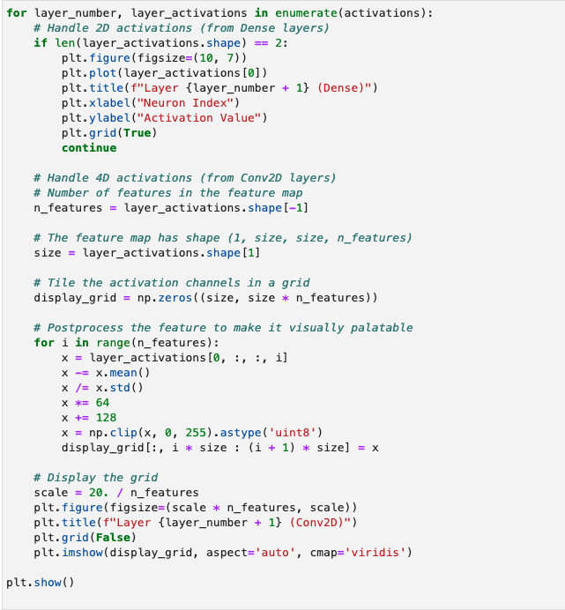

**Visualisations**

1. Convolution layers Activation maps

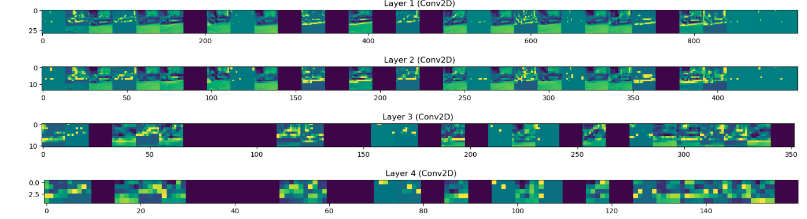

* **Layer 1 (Conv2D):** Displays the feature maps generated by the first convolutional layer, highlighting edges and simple textures.
* **Layer 2 (Conv2D):** Shows more complex patterns and shapes as the network progresses through the layers.
* **Layer 3 (Conv2D):** Features become increasingly abstract and represent higher-level information.
* **Layer 4 (Conv2D):** Further abstraction, capturing sophisticated image structures.

1. Dense Layer Activations

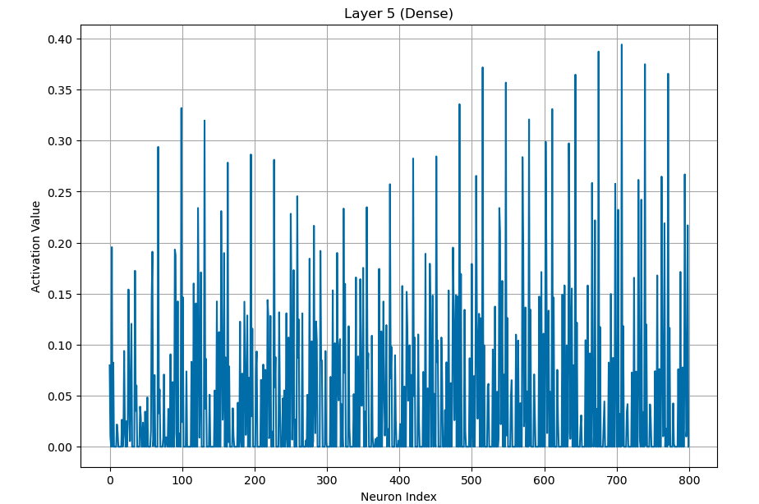

* **Layer 5 (Dense)**: The activations of the dense layer, showing how neurons respond to the extracted features.

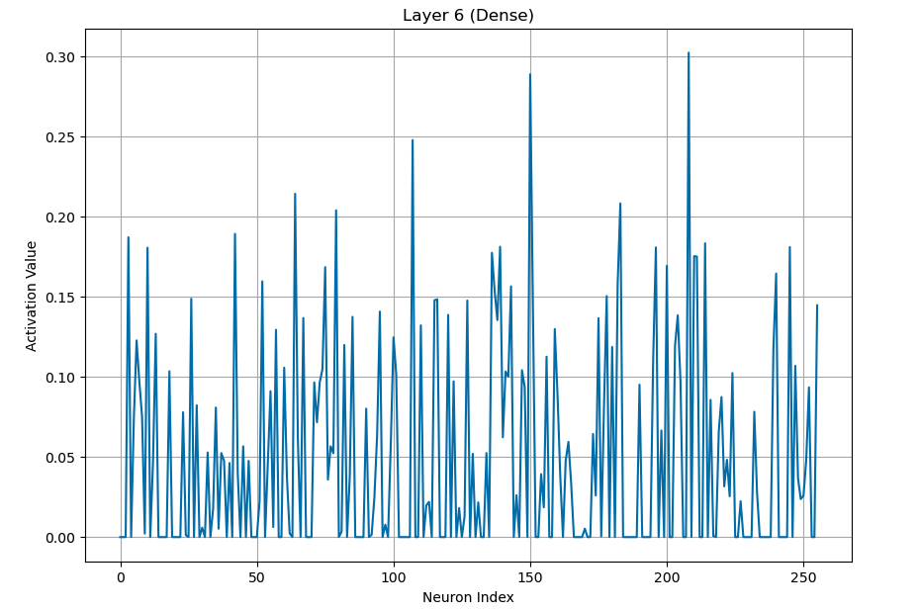

* **Layer 6 (Dense)**: Another dense layer visualization, illustrating different activation patterns.

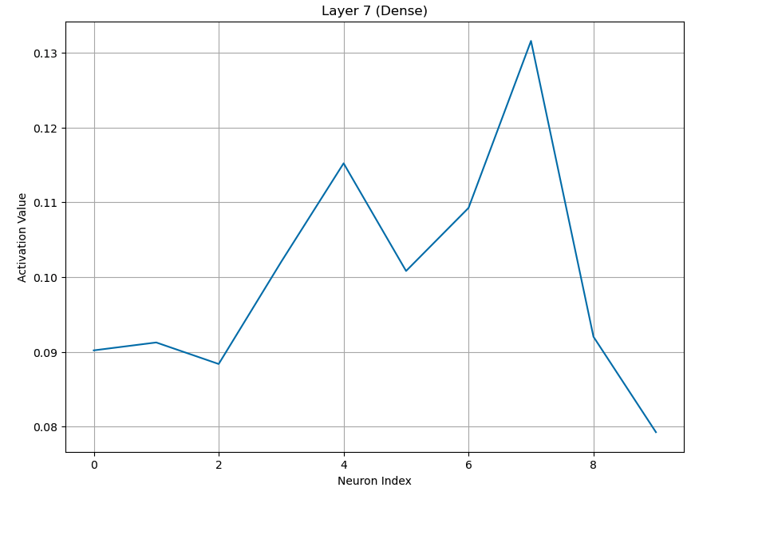

* **Layer 7 (Dense)**: Final dense layer before the output, summarising the learned features.